

*ParkSense: Arduino Embedded Parking Management System*

Project Documentation Submitted to the Faculty of the

School of Computing and Information Technologies

Asia Pacific College

In Partial Fulfillment of the Requirements for

Systems Analysis & Detailed Design for CS/IT

M/S SYADD1

By

|  |  |
| --- | --- |
| Rchie Libudan | John Jorel Landicho |
| Timothy Jay Sayson | Angela Mae Tauyan |

2024

Table of Contents

I. Introduction 1

1.1 Project Context 1

1.2 Statement of the Problem 1

1.3 Objectives 2

1.3.1. Main Objective 2

1.3.2. Specific Objectives 2

1.4 Significance of the Project 2

1.5 Scope and Limitations 4

II. Requirements Analysis 5

2.1 Dataflow Diagram 5

2.1.1 Level 0 5

2.1.2 Level 1 5

2.1.3 Level 2 6

2.2 Use Case Diagram 8

2.3 Fully Dressed Use Cases 9

2.3.1 Login into the System 9

2.3.2 View Reports 10

2.3.3 Detect Vehicle Entry 11

2.3.4 Detect Vehicle Exit 12

2.3.5 Record Parking Occupancy 12

2.3.6 See Available Parking Slot 13

2.4 Test Cases for Fully Dressed Use Cases 14

2.4.1 Login into the system 14

2.4.2 View Reports 15

2.4.3 Detect Vehicle Entry 15

2.4.4 Detect Vehicle Exit 16

2.4.5 Record Parking Occupancy 16

2.4.6 See Available Parking Slot 16

2.5 Activity Diagrams with Swimlane 17

2.5.1 Login into the system 17

2.5.2 View Reports 18

2.5.3 Detect Vehicle Entry 19

2.5.4 Detect Vehicle Exit 20

2.5.5 Record Parking Occupancy 21

2.5.6 See Available Parking Slot 22

2.6 Database Design 23

2.7 Product Backlog / User Stories 23

2.8 Partially Working Cloud Hosted Prototype 24

2.8.1 Log-in Page 24

2.8.2 Registration Page 25

2.8.3 Home Page 25

2.8.4 Django Admin Panel 26

2.9 Updates of Contents in Project GitHub Repository 26

2.10 Prototype 27

2.10.1 Technology Stack 31

2.10.2 GitHub Project Repository 32

2.11 Conclusion 32

Appendices 32

Appendix A: Project Vision 32

Appendix B: Schedule 33

Appendix C: Release Plan 34

Appendix D: Product Roadmap 37

Appendix E: Minutes of the Meetings 38

# Introduction

## Project Context

This project is for the client, namely the Building Maintenance Office, one of the offices in Asia Pacific College on the 10th floor of the building. Among their responsibilities are managing various facilities such as reservations, sewage, and basement parking. Upon approaching them, the client wants the developers to focus on basement parking and give them the processes and problems.

Currently, they are using a manual process in managing the basement parking. When a vehicle owner drives its way to the basement parking, upon entering it the security personnel commands it to stop and conducts an identification check to determine if the owner is an APC staff, student, guest, or an outsider. Follows the inspection of the underside of the vehicle. If the owner is an outsider, the security in charge will issue a parking ticket and will collect the parking fee. After all of that, they can proceed to the basement parking. After parking, the owner will surrender their valid ID to the security in the basement. Upon exiting the facility, the visitor will get their valid ID and hand over the parking ticket to the exit guard for verification of payment. Aside from those responsibilities, the officer in charge inspects each parking lot to determine whether they are vacant or occupied and informs the security personnel at the entrance about the status of the parking slots.

The mentioned processes take a lot of time to complete, and it is hassle for those who are in charge in both entrance and basement. With the wide space of the basement parking and having 2 levels of it, it takes a while before the officer-in-charge can update the status to the security personnel at the entrance which can cause a misinformation of the status that can possibly cause overcrowding within the basement parking.

With this automated parking tracking system, it will enhance the efficiency and accuracy of parking slot management, improving the overall experience for drivers and security personnel.

## Statement of the Problem

The Building Maintenance Office identified the problems related to the basement parking at Asia Pacific College. The problems they encounter include:

1. Not fully utilized parking space.
2. Lack of visibility into available parking slots.
3. Manual and inefficient process of checking parking availability.

## Objectives

### 1.3.1. Main Objective

ImPossible aims to automate the manual process of checking parking slot availability. By implementing this system, it will be easier to check the status in the basement parking area of Asia Pacific College, ensuring a more efficient and organized parking experience for everyone.

### 1.3.2. Specific Objectives

The specific objective of the project is to develop a tracking system that can help:

1. To advertise Asia Pacific College’s basement parking to the customer segments.
2. Install parking sensors and a monitoring system to provide real-time visibility of parking slot availability.
3. To reduce the reliance on manual labor for parking management tasks.

## Significance of the Project

If the project is implemented, the project will eliminate the client's manual process of checking basement parking availability. By providing a monitor to display the status of each parking slot, it will significantly reduce the staff's workload and improve overall efficiency.

Furthermore, the following roles will benefit from the project:

**Client**

As the manager of parking operations, this project will significantly enhance efficiency by automating the process of monitoring parking space availability, thereby reducing the need for manual checks. Additionally, it will offer valuable data analytics to understand parking usage patterns, enabling better planning and resource allocation.

**Vehicle Owners**

Most of the school's stakeholders have their own vehicles and require parking during each visit to the campus. This project will provide them with real-time information on parking availability, significantly reducing the time spent searching for parking spots and lowering gas consumption. Additionally, it will greatly enhance their overall satisfaction with the parking experience at Asia Pacific College.

**School**

Since the basement parking is located at Asia Pacific College, this project will enhance the operational efficiency of the parking facility, reflecting positively on the school's infrastructure. The integration of analytics will support informed decision-making regarding campus facilities and future developments, ensuring that resources are allocated effectively, and improvements are made based on data-driven insights.

**Future Developers**

Future developers will benefit from this project as it provides a solid baseline for further development and identifies areas for enhancement. It offers practical experience in developing and maintaining an embedded system. Additionally, they can collaborate with the same client for continuous improvement and ensuring the project evolves to meet the client's needs effectively.

**Sustainable Development Goals**

The proposed project aligns with the following Sustainable Development Goal (SDG):

**SDG 9: Industry, Innovation, and Infrastructure**

This project contributes to building resilient and sustainable infrastructure by enhancing and improving parking management through a technology solution.

**SDG 11: Sustainable Cities and Communities**

It enhances parking experience, making it more efficient and organized which contributes to safer and more accessible transportation systems within the school campus community.

**SDG 12: Responsible Consumption and Production**

This project optimizes parking spade usage and reduces time effort in looking for parking which promotes efficient resource use and reduces unnecessary fuel consumption.

## Scope and Limitations

This project intends to improve the efficiency and functionality of parking for individuals at Asia Pacific College. Our proposed solution will assist the Building Maintenance Office by developing an embedded system that will cover the basement parking with sensors per slot. These sensors will offer real-time updates to the monitor, which displays the available and occupied parking slots per basement level. The developers will also incorporate analytics into the project to establish how many spots were used on a daily, monthly, and yearly basis, allowing us to measure the effectiveness of basement parking and our project. This study's primary target includes the building maintenance office, information technology resource office, stakeholders, visitors, and students. The primary targets of this study include the building maintenance office, stakeholders, visitors, and students. The study will be conducted from the 2nd year, 3rd term to the 3rd year, 3rd term of our stay at Asia Pacific College. The project will be dependent and focused on what the developers and client agreed upon, as well as financial considerations. If further features are not agreed upon, they should be communicated to future project-based learners to improve the project and meet the client's needs

# Requirements Analysis

## 2.1 Dataflow Diagram

### 2.1.1 Level 0

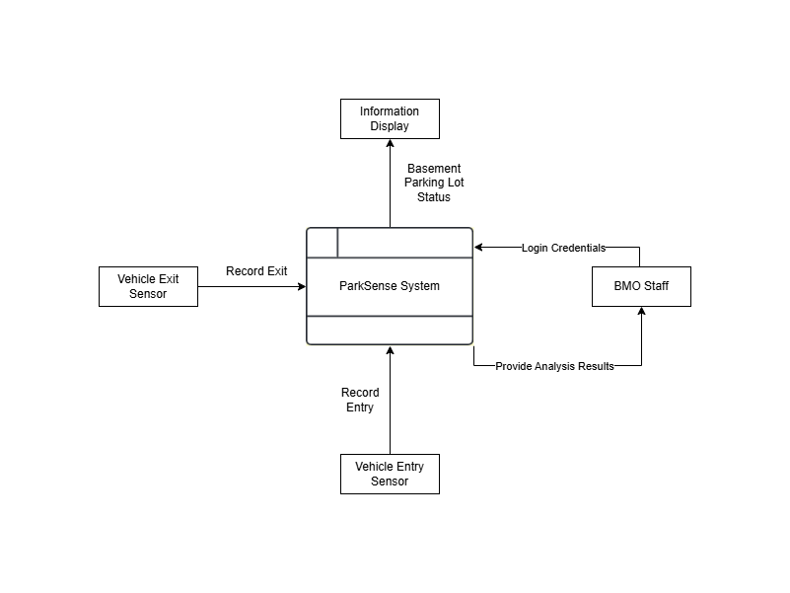

### 2.1.2 Level 1

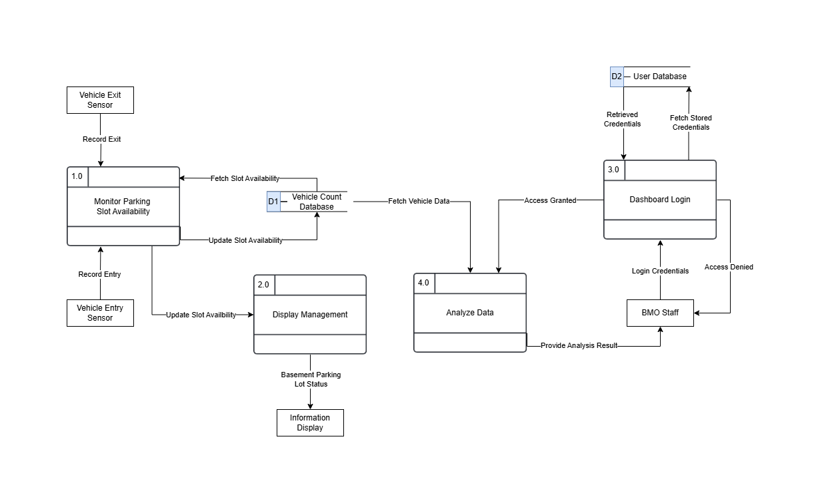

### 2.1.3 Level 2

#### 2.1.3.1 Monitor Parking Slot Availability

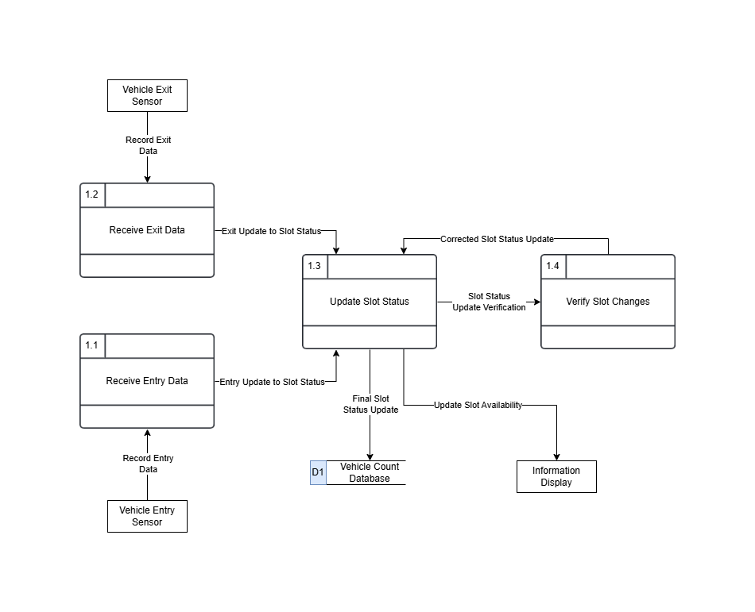

#### 2.1.3.2 Dashboard Login

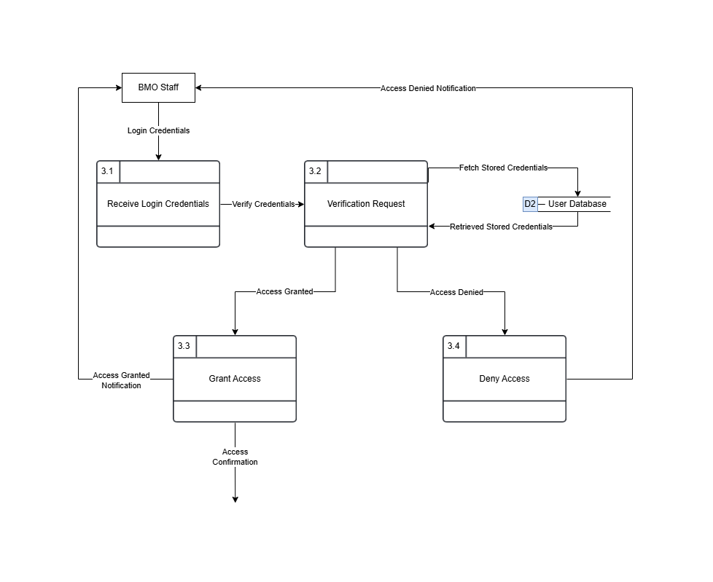

#### 2.1.3.3 Analyze Data

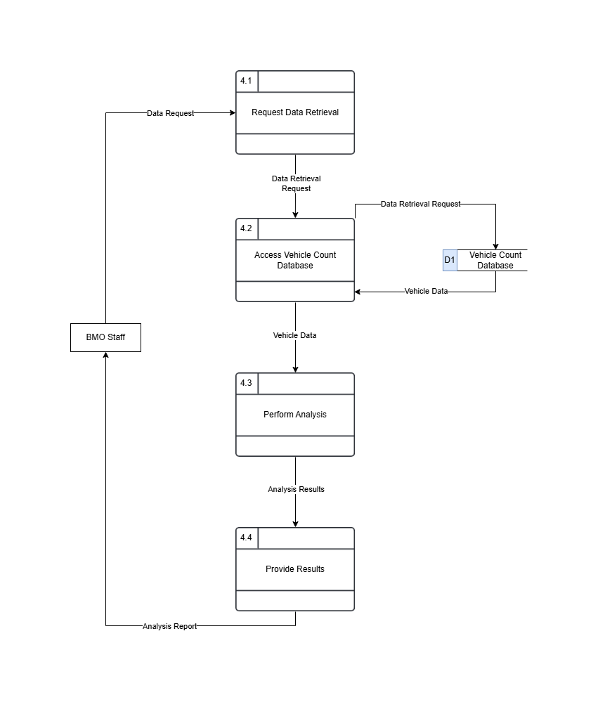

## 2.2 Use Case Diagram

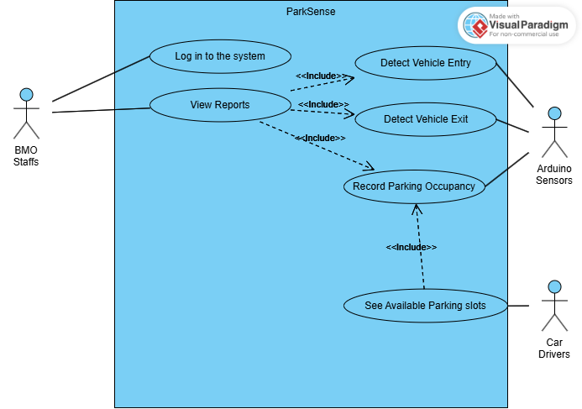

## 2.3 Fully Dressed Use Cases

### 2.3.1 Login into the System

|  |  |
| --- | --- |
| Use Case ID | PAS_UC_1 |
| Use Case Name | **Login in to the system** |
| Created By | John Jorel Landicho |
| Date Created | 9/16/2024 |
| Description | This use case describes the process of logging into the ParkSense system, allowing authorized users (BMO Staff) to access specific system functions after successful authentication. |
| Primary Actor | BMO Staff |
| Preconditions | 1. The Park Sense system is operational. 2. The user has a valid username and password. |
| Postconditions | **Success**: The user is logged into the system and can perform their assigned tasks.    **Failure**:The system denies access, and no tasks can be performed until a successful login. |
| Main Success Scenario (Basic Flow) | 1. The actor (BMO Staff) opens the ParkSense system login screen. 2. The system displays fields for the username and password. 3. The actor inputs their username and password. 4. The system checks the entered credentials against its database. 5. The system confirms that the credentials are correct and logs the actor into the system. 6. The actor is redirected to the appropriate dashboard based on their role (e.g., BMO Staff is directed to the dashboard for analyzing data;). |
| Extensions (Alternate Flows) | 2a. **Invalid Credentials:**   * **Trigger:** The user enters an incorrect username or password. * **Action:** The system detects that the credentials do not match the database records. * **Response:** The system displays an error message ("Invalid username or password") and prompts the user to retry. |
| Special Requirements | 1. Passwords should follow security protocols (e.g., minimum length, complexity requirements). 2. The login interface should be simple and user-friendly. |

### 2.3.2 View Reports

|  |  |
| --- | --- |
| Use Case ID | PAS_UC_2 |
| Use Case Name | **View Reports** |
| Created By | **ImPossible**: John Jorel Landicho, Rchie Libudan, Angela Mae Tauyan, Timothy Jay Sayson |
| Date Created | 11/01/2024 |
| Description | This use case allows BMO Staff to view reports based on parking data collected by the system. |
| Primary Actor | BMO Staff |
| Include Use Case | 1. Detect Vehicle Entry 2. Detect Vehicle Exit 3. Record Parking Space Occupancy |
| Preconditions | 1. The Park Sense system is operational and has logged sufficient data. |
| Postconditions | **Success:** Accurate and comprehensive reports are generated.    **Failure:** Reports are missing key information or contain errors. |
| Main Success Scenario (Basic Flow) | 1. BMO Staff selects the "View Reports" option. 2. The system retrieves historical occupancy and usage data. 3. The system displays the data in a report format. |
| Extensions (Alternate Flows) | 2a. **Report Contains Errors or Missing Data:**   * **Trigger:** The system notifies the BMO Staff that there is no data available. * **Action:** The BMO Staff adjusts the report parameters or requests system maintenance. * **Response:** A corrected report is generated. |
| Special Requirements | 1. The reporting tool should support different formats (PDF, Excel). 2. Reports should include visual aids like charts and graphs for easy interpretation. |

### 2.3.3 Detect Vehicle Entry

|  |  |
| --- | --- |
| Use Case ID | PAS_UC_3 |
| Use Case Name | **Detect Vehicle Entry** |
| Created By | **ImPossible**: John Jorel Landicho, Rchie Libudan, Angela Mae Tauyan, Timothy Jay Sayson |
| Date Created | 11/01/2024 |
| Description | Detects when a vehicle enters the parking facility and updates occupancy data. |
| Primary Actor | Arduino Sensors |
| Preconditions | 1. Arduino sensors are functional and calibrated. |
| Postconditions | **Success:** The system records a new vehicle entry and updates parking occupancy.    **Failure:** The system fails to record  new vehicle entry and not update the parking occupancy. |
| Main Success Scenario (Basic Flow) | 1. A vehicle passes through the entry point. 2. The Arduino sensor detects the vehicle's entry. 3. The system increments the count of occupied parking slots. |
| Extensions (Alternate Flows) | 2a. **If the sensor fails to detect a vehicle entering:**   * **Trigger:** The system prompts BMO Staff to check the entry status. * **Action:** The BMO Staff check the actual device and do some maintenance. * **Response:** Updates the occupied parking slots. |
| Special Requirements | 1. The system must update occupancy within 2 seconds of detection. |

### 2.3.4 Detect Vehicle Exit

|  |  |
| --- | --- |
| Use Case ID | PAS_UC_4 |
| Use Case Name | **Detect Vehicle Exit** |
| Created By | **ImPossible**: John Jorel Landicho, Rchie Libudan, Angela Mae Tauyan, Timothy Jay Sayson |
| Date Created | 11/01/2024 |
| Description | Detects when a vehicle exits the parking facility and updates occupancy data. |
| Primary Actor | Arduino Sensors |
| Preconditions | 1. Arduino sensors are functional and calibrated. |
| Postconditions | **Success:** The system records the vehicle exit and updates parking occupancy.    **Failure:** The system fails to record  vehicle exit and not update the parking occupancy. |
| Main Success Scenario (Basic Flow) | 1. A vehicle passes through the exit point. 2. The Arduino sensor detects the vehicle's exit. 3. The system decrements the count of occupied parking slots. |
| Extensions (Alternate Flows) | 2a. **If the sensor fails to detect a vehicle exiting:**   * **Trigger:** The system prompts BMO Staff to check the exit status. * **Action:** The BMO Staff check the actual device and do some maintenance. * **Response:** Updates the occupied parking slots. |
| Special Requirements | 1. The system should reflect the updated count within 2 seconds. |

### 2.3.5 Record Parking Occupancy

|  |  |
| --- | --- |
| Use Case ID | PAS_UC_5 |
| Use Case Name | **Record Parking Occupancy** |
| Created By | **ImPossible**: John Jorel Landicho, Rchie Libudan, Angela Mae Tauyan, Timothy Jay Sayson |
| Date Created | 11/01/2024 |
| Description | Records current parking occupancy based on vehicle entries and exits. |
| Primary Actor | Arduino Sensors |
| Preconditions | 1. ParkSense system is active and logging entry/exit data. |
| Postconditions | **Success:** The parking occupancy is accurately recorded and available for reporting.    **Failure:** The system fails to accurately record the parking occupancy. |
| Main Success Scenario (Basic Flow) | 1. The system tracks each vehicle entry and exit. 2. The occupancy data is updated in real-time. 3. The system logs the occupancy status for historical reporting. |
| Extensions (Alternate Flows) | 1a. **If there is an inconsistency in the entry/exit count:**   * **Trigger:** The system alerts BMO Staff for manual verification. * **Action:** BMO Staff logs into the system and reviews the data. * **Response:** BMO Staff performs a manual override to correct the occupancy count if necessary. |
| Special Requirements | 1. Data must be stored in a secure database accessible only by authorized personnel. |

### 2.3.6 See Available Parking Slot

|  |  |
| --- | --- |
| Use Case ID | PAS_UC_6 |
| Use Case Name | **See Available Parking slots** |
| Created By | **ImPossible**: John Jorel Landicho, Rchie Libudan, Angela Mae Tauyan, Timothy Jay Sayson |
| Date Created | 11/01/2024 |
| Description | Allows Car Drivers to view available parking slots displayed at the entrance. |
| Primary Actor | Car Drivers |
| Include Use Case | 1. Record Parking Occupancy |
| Preconditions | 1. ParkSense system is operational and updated in real-time. |
| Postconditions | **Success:** Car Drivers are informed of the number of available slots.    **Failure:** The system fails to accurately record the parking occupancy, leading to inconsistent slot availability information for Car Drivers |
| Main Success Scenario (Basic Flow) | 1. The system calculates the available parking slots based on occupancy data. 2. The system updates the display board with the current count of available slots. |
| Extensions (Alternate Flows) | 1a. **If the display board is malfunctioning:**   * **Trigger:** The system detects an issue with the display board. * **Action:** The BMO Staff performs diagnostic checks or repairs to restore functionality. * **Response:** Display board is working and updated. |
| Special Requirements | 1. Display visibility must meet local safety standards and be readable from at least 10 meters away. |

## 2.4 Test Cases for Fully Dressed Use Cases

### 2.4.1 Login into the system

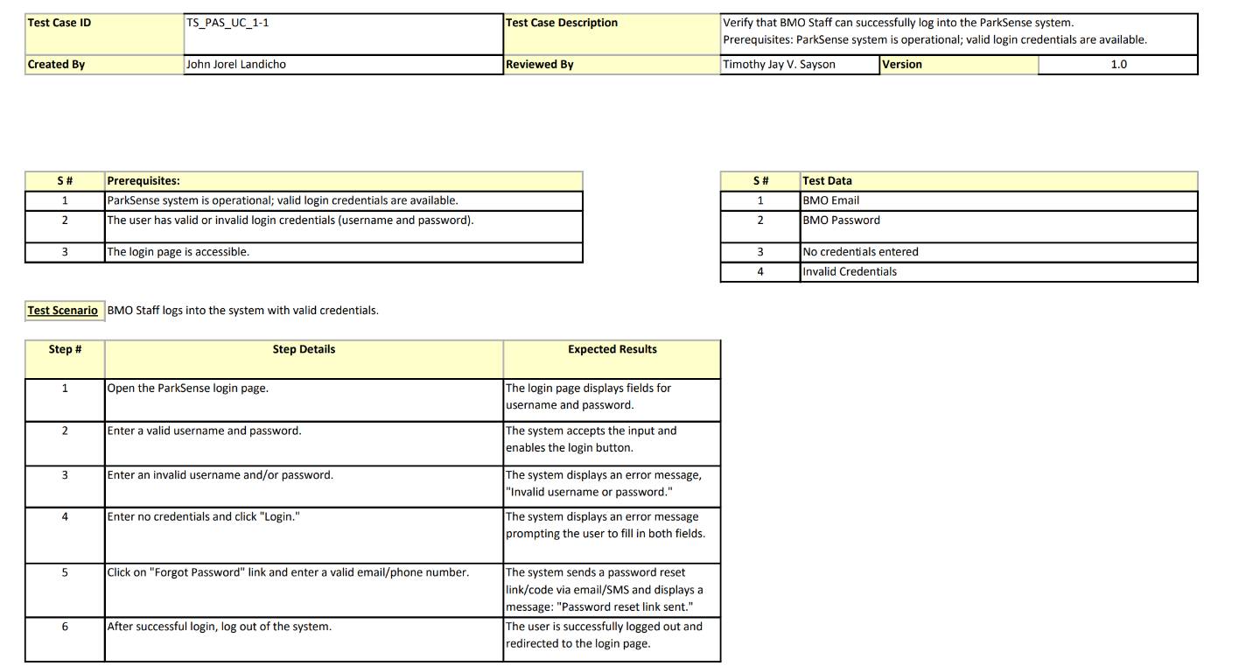

### 2.4.2 View Reports

### 2.4.3 Detect Vehicle Entry

### 2.4.4 Detect Vehicle Exit

### 2.4.5 Record Parking Occupancy

### 2.4.6 See Available Parking Slot

## 2.5 Activity Diagrams with Swimlane

### 2.5.1 Log in into the system

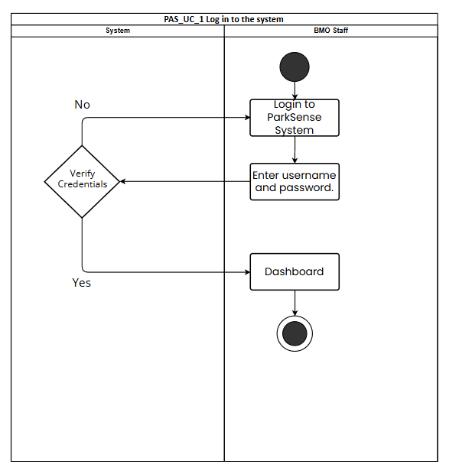

### 2.5.2 View Reports

### 2.5.3 Detect Vehicle Entry

### 2.5.4 Detect Vehicle Exit

### 2.5.5 Record Parking Occupancy

### 2.5.6 See Available Parking Slot

## 2.6 Database Design

## 2.7 Product Backlog / User Stories

Table I Product Backlog

|  |  |  |  |  |
| --- | --- | --- | --- | --- |
| ID | As a… | I want to be able to… | So That… | Priority |
| 1 | Parking User | Use the parking facility | I can park my vehicle quickly and securely | Must |
| 2 | Parking User | Authenticate my identity | I can access the parking facility | Must |
| 3 | Parking User | Report issues | Any problems can be addressed quickly | Should |
| 4 | BMO Staff | Analyze data | I can make informed decisions based on the data given | Must |
| 5 | BMO Staff | Generate reports | I can provide detailed information to stakeholders | Should |
| 6 | BMO Staff | Oversee maintenance | The parking facility is maintained regularly and efficiently | Should |

## 2.8 Partially Working Cloud Hosted Prototype

2.8.1 Log-in Page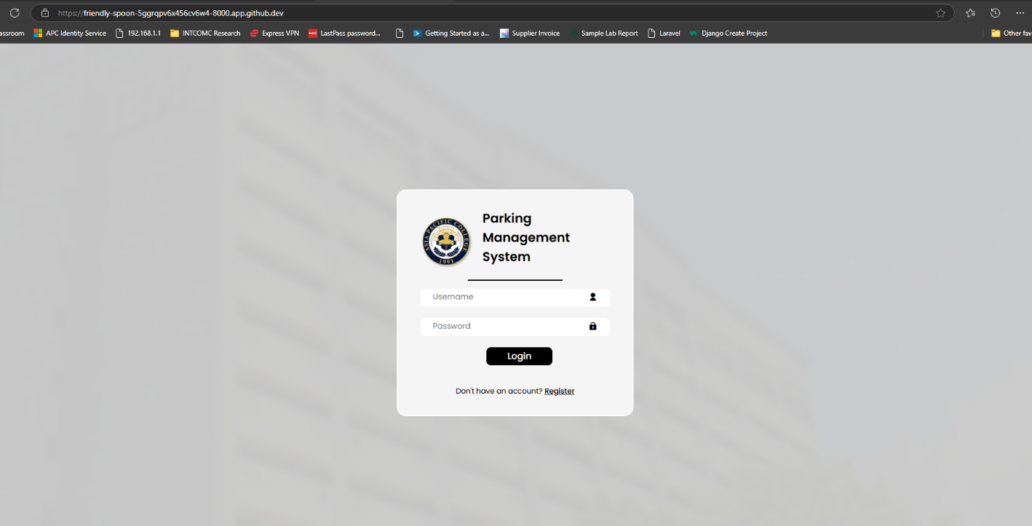

### 2.8.2 Registration Page

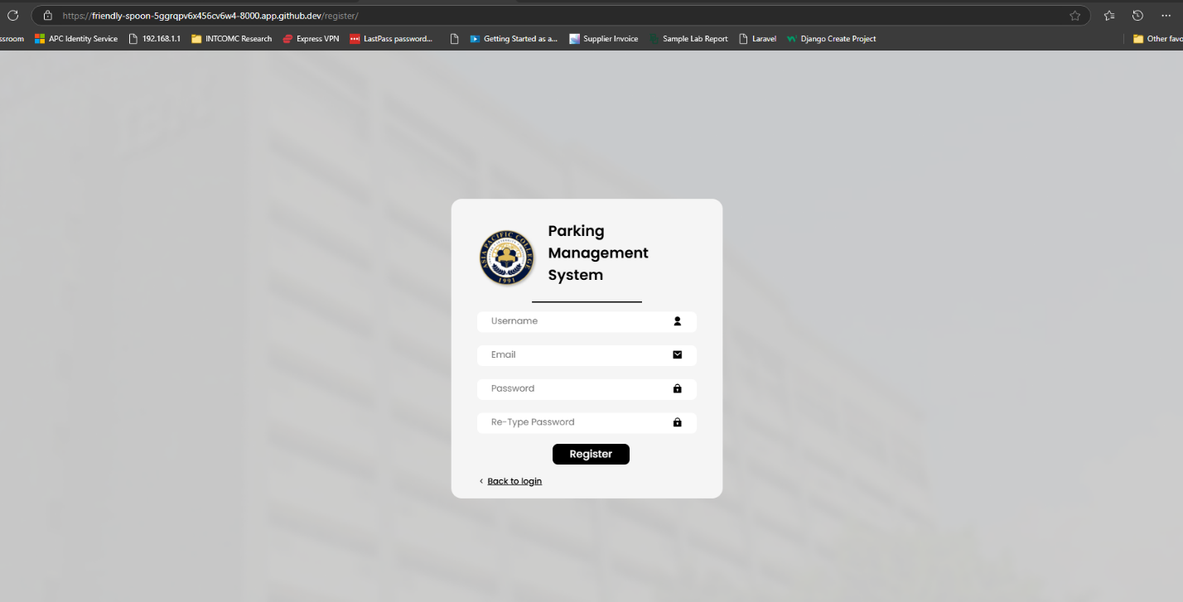

2.8.3 Home Page  
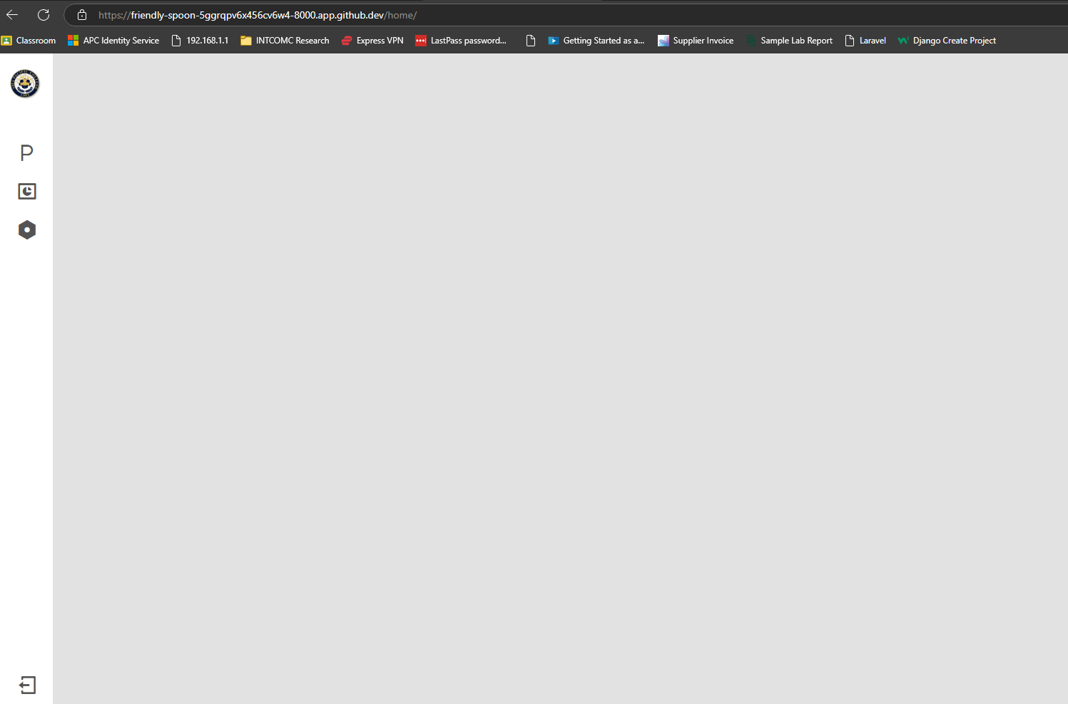

### 2.8.4 Django Admin Panel

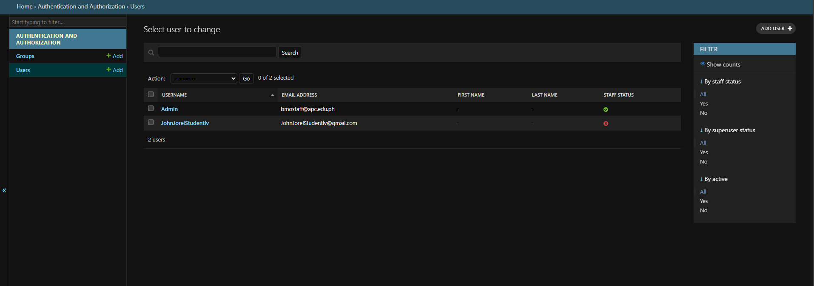

## 2.9 Updates of Contents in Project GitHub Repository

<https://github.com/APC-SoCIT/APC-2024-2025-T1-06-ParkSense>

## 2.10 Prototype

Figure 2 Prototype: Tracker Display

Figure 3 Prototype: Dashboard

Figure 4 Prototype: Basement 1 Display

Figure 5 Prototype: Basement 2 Display

Figure 6 Prototype: Basement 1 Slots Taken

Figure 7 Prototype: Analytics

Figure 8 Prototype: Schematic Diagram

### 2.10.1 Technology Stack

1. Frontend:

* **HTML, CSS, JavaScript:** Standard web technologies for structure, styling, and interactivity.

2. Backend:

* **Django Framework (Python):** Used for building the entire web application with its backend feature and server-side logic.

3. Database:

* **SQLite:** A built-in database in Django

4. Authentication:

* **Django Authentication:** A built-in authentication system to handle user authentication authorization

5. Version Control:

* **Git:** For tracking changes in code.
* **Github:** Used for tracking, branching, merging codes, and collaborating with other developers.

### 2.10.2 GitHub Project Repository

The link below is the team’s collaborative space for their project.

ImPossible GitHub repository link: <https://github.com/APC-SoCIT/APC-2024-2025-T1-06-ParkSense>

## 2.11 Conclusion

The development of parking sensors and other advanced parking technologies is crucial for addressing the persistent challenges associated with finding parking in urban areas. These innovations offer significant benefits, including reducing search time, alleviating traffic congestion, and minimizing environmental impacts. By understanding and managing the effects on various stakeholders, such as students, faculty, and the local community, schools and other institutions can effectively navigate the complexities of these technological improvements. As the reliance on personal vehicles continues to grow, the adoption of smart parking solutions becomes increasingly essential for enhancing urban transportation efficiency and sustainability.

The successful implementation of this project can serve as a stepping stone for the improvement of our school's basement parking, allowing future PBL students to further improve and add additional features to the basement parking once the BMO receives all of the data and analytics on its usage.

# Appendices

## Appendix A: Project Vision

Our vision is to utilize innovative methods to make parking at Asia Pacific College more convenient, efficient, and user-friendly. Our goal is to create a completely automated parking management system that combines modern technology with the subjects we studied at Asia Pacific College. This contains sensors for each parking slot, display trackers to keep track of available slots on each basement level, and a real-time monitoring system that provides analytics and indicates whether or not the basement level is filled. By deploying this system, we want to improve the security and overall experience of all target users. The initiative aims to enhance campus parking by promoting a more orderly and sustainable environment.

## Appendix B: Schedule

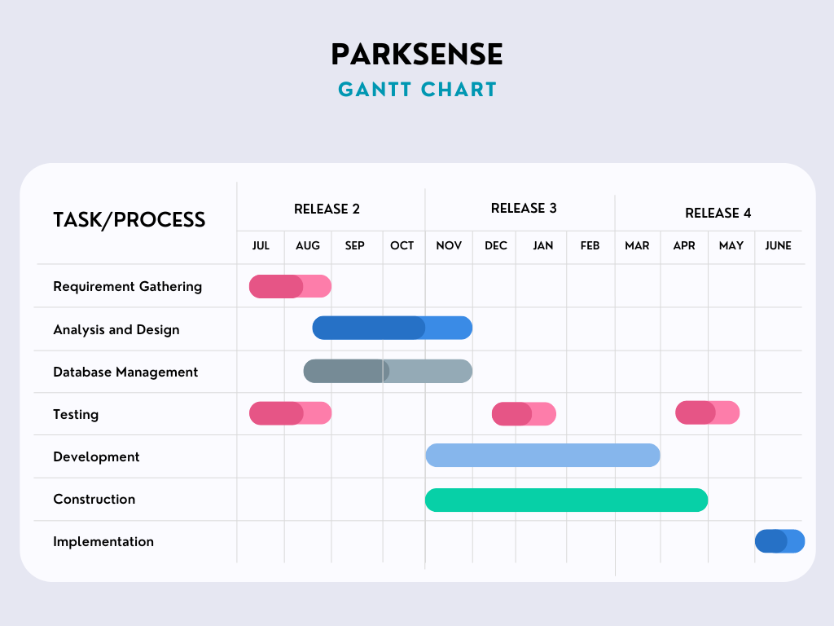

Figure 9 Release Plan

## Appendix C: Release Plan

The release plan for our proposed system will be divided into four terms of the Project Based Learning courses based on the academic calendar for the Bachelor of Science in Information Technology with Specialization in Mobile and Internet Technologies 2022. This plan will include the milestones, deliverables, and timelines for each phase of the whole Project Based Learning course. Refer to Appendix B for the project's Gantt Chart  and Appendix C for the product roadmap.

**Target Group:** Building Maintenance Office (BMO)

**Goal**: To create a completely automated parking management system that combines modern technology with the subjects we studied at Asia Pacific College. This contains sensors for each parking slot, display trackers to keep track of available slots on each basement level, and a real-time monitoring system that provides analytics and indicates whether or not the basement level is filled.

**Needs:**

* Real-time monitoring and analytics of parking usage
* Reduction of manual checking for available slot for BMO
* Precise and dependable data from trackers and sensors.
* Efficient management of parking spaces.

**Values:** ParkSense will allow the Building Maintenance Office (BMO) to simply examine the state of the basement parking spots without having to walk down and roam around. The technology will also allow them to measure how many students, staff, stakeholders, and visitors utilize our basement parking on a daily, monthly, and annual basis.

**Key Features:** Sensor integration, Display tracker, Real-time monitoring system, User interface with analytics and reporting

**Release Plan**

**Release 1**

* Research Paper
* Prototype

**Release 2**

* Designing the website interface
* Hardware acquisition and setup
* Integration of the system components
* Implementation of database system

**Release 3**

* Development of website interface
* Testing and troubleshooting
* Preparation of local/cloud server

**Release 4**

* Final testing
* Deployment and installation
* Project video teaser
* Training for BMO staff

## Appendix D: Product Roadmap

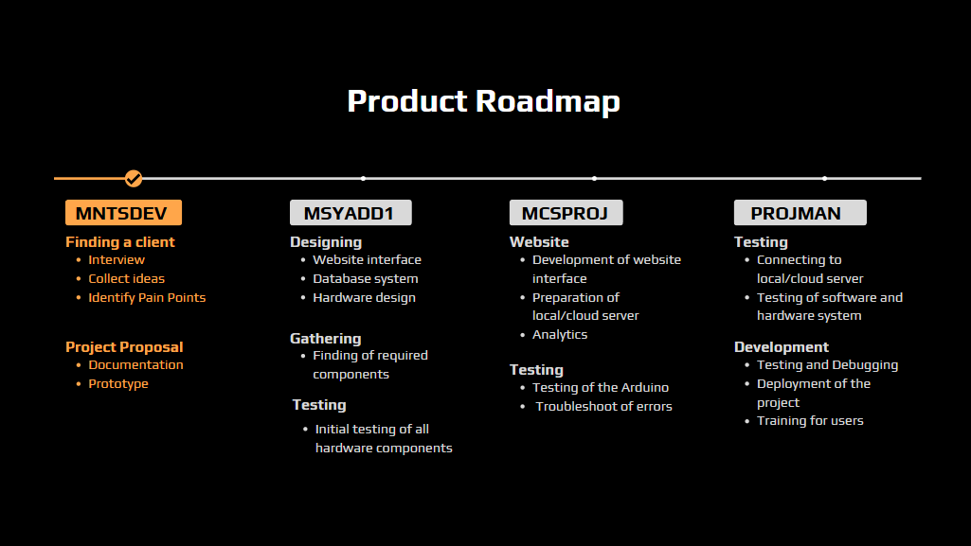

Figure 10 Roadmap

## Appendix E: Minutes of the Meetings

|  |  |
| --- | --- |
| Date | Minutes of the Meeting |
| August 12, 2024 | * Identifying of Tasks * Assigning of Tasks * Creation of Timeline * TJ to ask for Sir Alvin's available time for this week or next week * Angela/JJ to ask for the client's and ITRO available time from this week till next week * Whole group will find and gather materials from 4th week of August to 1st week of September * TJ will try to use the arduino wifi for the first code on the 4th week of August or 1st week of September |
| August 19, 2024 | * Revising of Initial DFD * Start of Creating Fully Dressed Use Case * The group is waiting for the reviewed DFD before revising it and will follow up the adviser tomorrow * The group will rewatch the dressed use case video and will start doing it by Thursday or Friday |
| August 29, 2024 | * Assigning of tasks * All groupmates have 1 fully dressed use case to create test case. It should be done before Monday. * Rewatch or re-read the given links provided today |
| September 23, 2024 | * Planning of meeting with the adviser * Discussion of what additional features should be our backup plan * Find another back up client * Erd planning * Overthinking the project whether to proceed * Face to face meeting with adviser on Friday (September 27,2024) * Revise what needs to be revised |
| October 06, 2024 | * Revision * Framework * Final presentation reminders * All diagrams should be finalized by next week, assigned to all |
| October 13, 2024 | * Consultation * Framework * Frappe could be the possible framework for the website * Other half of the diagrams should be done till the end of this week by the members |
| October 20, 2024 | * Revision of diagrams * Framework * Revision of diagrams Sayson, Tauyan, and Libudan should be done on or before Thursday this week * Watch all the videos about Django before Wednesday for all members * Should started programming Django before this week ends all members |